Meta Title:
Professional Brake calliper Paint & Refurbishment Services
Meta Description:
Get exclusive Brake Caliper Paint & Refurbishment Services from the most experienced company in the UK. Moreover, available in DIY colour Options.

Brake Caliper paint
Brake calliper paint | 260 | 21%
Brake Caliper painting near me | 70 | 3%
painted Callipers | 390 | 26%
painted brake callipers | 480 | 25%
brake calliper refurbishment | 1k | 22%
rake Caliper paint colours | 140 | 12%
green Caliper paint | 110 | 3%
silver calliper paint | 90 | 13%
black painted Callipers | 90 | 6%
red brake callipers | 480 | 5%
blue brake callipers | 210 | 8%

Brake Caliper Paint Services | Add Color, Add Style
If you are searching for “brake calliper painting near me” services for your vehicle then we are the best choice in the UK. Just tell us about your requirements or you can even visit our brake calliper paint kits shop to unlock the inner beauty of your brakes.
✅ Fast Turnaround Time
✅ Increased Protection
✅ Full Sets Painted From £240+VAT

Let’s Transform, Enhance, and Protect Your Vehicle!
Are you ready to add new life to Your Vehicle with Our Stunning Custom painted callipers? Our paint can protect your vehicle calliper from corrosion and rust effects. Moreover, it also provides a brand-new look to your vehicle. You can get our custom-painted brake callipers to provide an ultimate professional look to your luxury or sports car. Our expert painters have decade-long expertise in this field and worked on a number of cars ranging from Supercars to Prestige cars. Furthermore, we did our work to the highest of standard and ensured high quality. If you are from Greater Manchester, Merseyside, Cheshire, and Lancashire, you can visit our stores to get our services.

Our Deliverable Brake Caliper Refurbishment Services:
You can get our brake or brake calliper paint colours services that come with a Lifetime Warranty. Our experts will make your brake shine like a jewel.
Repair & Un-Seize Services | Re-Manufacture Services | High-End Brake Caliper Painting Services
Why pay for complete brake piston refurbishment when your brake pistons need just a minor repair? Save your money and get your minor seizing piston problems quickly fixed at a lower cost by getting our Repair & Un-Seize Services. | If you feel for complete refurbishment from bleed nipples to rubber parts then you can get our exclusive re-manufacture services. Moreover, we make sure about the working condition of your current piston and suggest whether it can be replaced or re-used. | We offer exclusive OEM colour options for brake callipers which include:  - Blue Brake Calipers  - Red Brake Calipers  - Black Painted Callipers  - Silver Caliper Paint  - Green calliper Paint  Moreover, we also provide decal options in custom styles and bespoke colours suitable to your needs.

How Does It Work?
Our brake Caliper painting process is very unique and that's the reason why we are the best among the best. Before we paint your brake callipers our experts first dismantle and remove them. After the removal process is completed they are sandblasted to remove any traces of rust, dust, and previous coating layers. Then we start the cleaning and inspection process and after that, we paint them in colours of your interest or choice.
We start the finishing or rebuilding process once the paint has been dried after a thorough inspection. Once this process of rebuilding ends, we start to add contrasting colours, pad guides, and slide pins.
After we put your brake Callipers back into your vehicle then we add some ceramic grease into suitable places and finish the wheel refitted process.
Then our experts do a road test of the car for diagnostic purposes and check everything is working smoothly.

Next Step On This Journey!
If you have any questions in mind or are ready to get our brake paint Caliper services then you can reach out to us through our website form or contact number. Given below is our quote request process to reach out to us:

Contact Us | Tell Your Requirements | Get Quote | Witness Magic
First, you can contact us through our website, contact us, or even visit our shop personally. | After that, you can tell us about your requirements for colours, decals, and the nature of services needed. | Once we have your requirements, we prepare a quoted price per your project and start working on it after confirmation. | Within the minimum possible time, we will deliver your vehicle once we complete the project thoroughly.
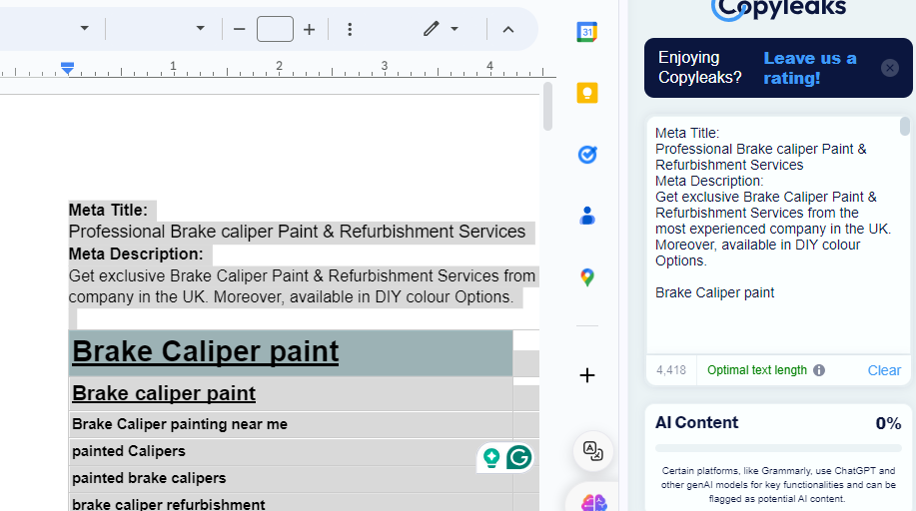

FAQ’s

What kind of colours is available for brake caliper paint?
The brake caliper paint we provide is highly durable, and you can find many different colours to suit your car. Among the most preferred choices are: red, yellow, green, orange, blue, purple, black and white and any mix of the two. Please, do not hesitate to tell us what color you desire!

How long does it take to paint the brake caliper?
Painting may take 2-3 days depending on the size of the home and the complexity of the design chosen. We take off the calipers, wash and get the surfaces ready, paint several layers of high temp paint, and put the calipers back on your vehicle once they are dry.

Is the sort of paint you apply on brake calipers heat-resistant?
Yes, we use specialized brake caliper paint that is heated, chip and abrasion-resistant to withstand the demands of your braking system at temperatures up to 900°F.

Will the brake rotors require resurfacing after painting?
As a matter of fact, in a majority of the cases, brake rotor resurfacing is not required. In painting, we cover the rotors. In essence, you might not require rotors surfaced as long as they are in acceptable condition before the race.

